Postprocessor User's Guide for
Makino V22, V33, V66, V77, V99, S33, S66, GF6, GF8, GF12

This is a 3-Axis Milling Machine.
In order to use this postprocessor correctly, you should follow the instruction below.
- Add the GI MODE UDE to the operation
  - Highlight the operation which you want to turn GI MODE on, using MB3, select OBJECT→ Start Events. The User Defined Events dialog is displayed.
  - 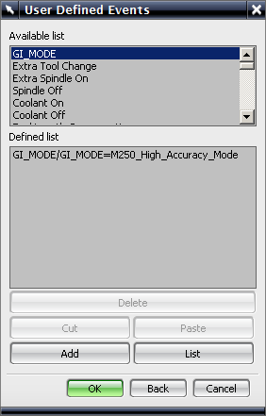
  - Select ‘GI_MODE’ from the Available list items, then chooses the Add button.
Select GI_MODE, M250 for High Accuracy Mode, and M251 for High Speed Mode.
  - 